Supplies needed for a
Feeder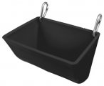
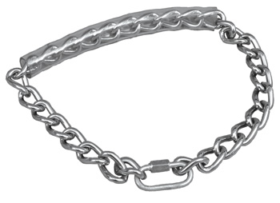Goat Chain
goat owner:

- Water bucket with clip
- Feeder with clips
- Pine shavings – You will need to change shavings at least every other week.
- Goat Chain
- Goat blanket
- Muzzle
- Antibacterial soap – this can be liquid dish soap, the cheap stuff will do, it is just for washing before you shave your animal.
- Spray conditioner or liquid conditioner- for after shaving
- Feed
- Hay – alfalfa, one small handful a day
- Official FFA Jacket – order from National FFA.org
- Show Official Dress –
  - Black pants – jeans or dress pants
  - White collared shirt
  - Solid black boots or shoes
Type of clip others can be used.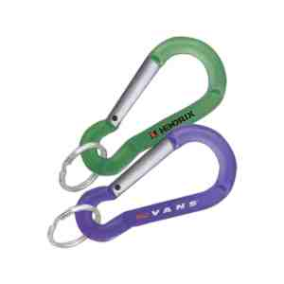
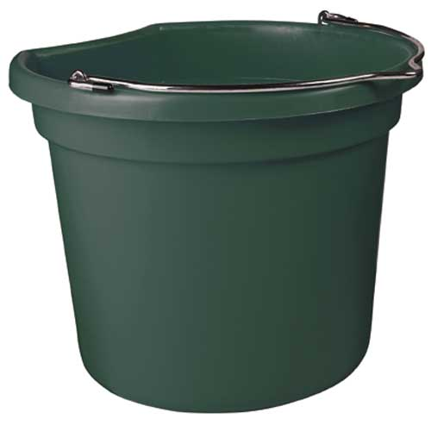
Water Bucket

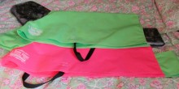
Goat Blanket
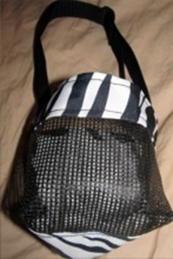
Muzzle

